GAUSS SEIDEL METHOD

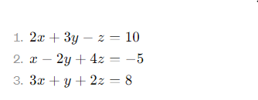  
FIRST ITERATION  
 x = (10+z-3y)/2 (set y=z=0)  
 y = (-5-4z-x)/-2 (set y=0,calculated=x)  
 z = (8-y-3x)/2 (calculated x,y)  
SECOND ITERATION  
 x = (10+z-3y)/2 the previous calculated y is used to compute (10-3y)/2 coz   
z will not be available at that time.  
 y = (-5-4z-x)/-2 similarly here x is used waits for z   
 z = (8-y-3x)/2 similarly here x is used waits for y,z (happens after t=1,instant when x is computed)